
- Muhammad Hamza Qamar, Roll No: 2025-CS-123
- Saad Mahmood, Roll No: 2025-CS-120
- Malik Aliyan Zawar ,Roll No: 2025-CS-166
- Muhammad Abdullah Siddique, Roll No: 2025-CS-130
- Muhammad Sheharyar, Roll No: 2025-CS-154
- Abdul Hannan, Roll No: 2025-CS-121

submitted in the partial fulfillment of the requirements for aict.
instructor: mISS ramsha khalid
date of submission: 20 November,2025
UNIVERSITY OF ENGINEERING AND TECHNOLOGY, LAHORE

problems faced by university freshers: a survey report and analysis.



TABLE OF CONTENTS

- Introduction……………………………………………………………………………2
- Data Summary and Observations ……………………………………………………..3
- Findings and Discussion……………………………………………………………….9

- Conclusion and Suggestions…………………………………………………………...10

INTRODUCTION

Starting university life is one of the most exciting yet challenging experiences for students. Every year, new students commonly known as freshers enter university with great enthusiasm and expectations. However, the transition from school or college to university often brings several difficulties that can affect their academic performance, emotional well-being and social adjustment.
This report, titled 'University Fresher Problem Report' aims to identify and analyze the common problems faced by first-year university students. These may include academic stress, accommodation issues, homesickness, time management challenges, financial difficulties , and adjusting to a new social environment.
Through this survey, we collected responses from various university students to understand their experiences and concerns as freshers. The data gathered helps us observe the frequency and types of problems faced, analyze patterns among students, and suggest possible solutions for smoother adaptions into university life.
The purpose of this report is to highlight these issues and provide useful insights for both the university administration and incoming students, ensuring a more supportive and comfortable environment for future freshers.





Data Summary and Observation

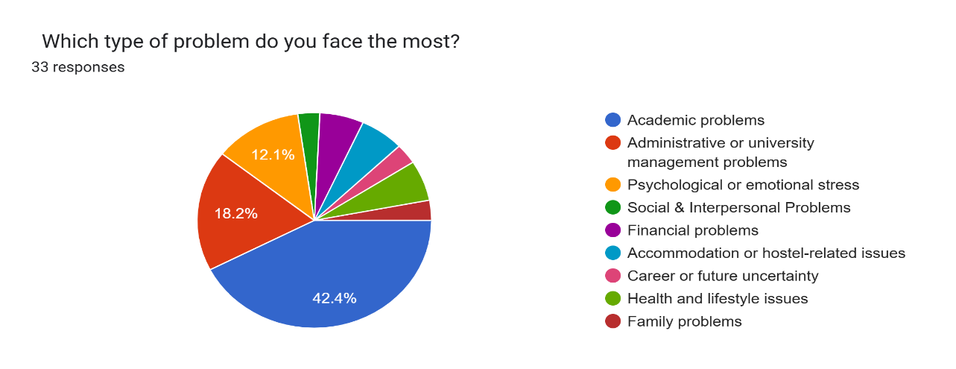

1. Academic Problems (42.4% of all reported issues)
The primary academic challenges are equally distributed across three major areas, indicating a systemic issue that goes beyond just one factor:
- Teaching & Understanding (48.5%): A significant portion of problems relate to the teaching style and understanding, specifically: difficulty understanding lectures, fast teaching pace/unclear explanations, and language barriers.
- Study Skills (42.4%): Issues with personal study habits are also highly prevalent, including poor time management, struggle with note-taking or research work, and difficulty adapting from rote learning to conceptual learning.
- Course Load (42.4%): The quantity and balance of work is a concern, specifically citing too many subjects or assignments at once and a lack of balance between theory and practical work.

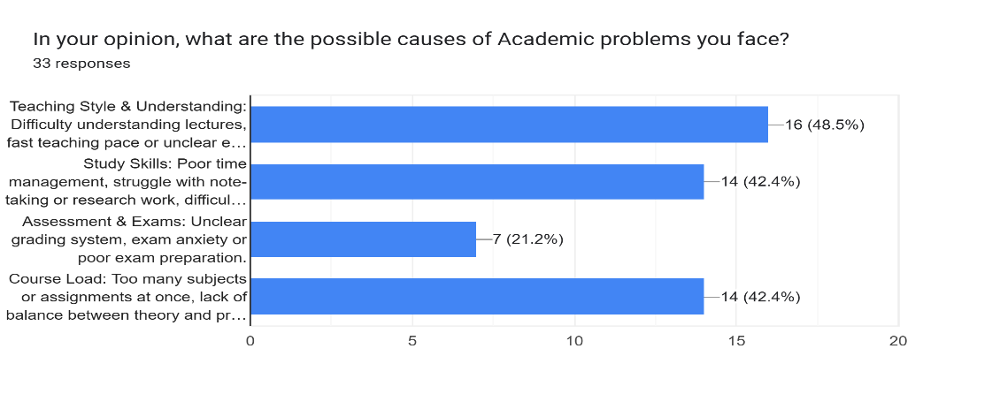

2. Psychological or Emotional Stress (12.1% of all reported issues)
- Academic Pressure (84.8%): Two-thirds of all psychological issues center on pressure to perform well academically and fear of failure or letting family down.
- Self-Esteem & Comparison (24.2%): Students frequently report comparing oneself with others and feeling not good enough for university standards.
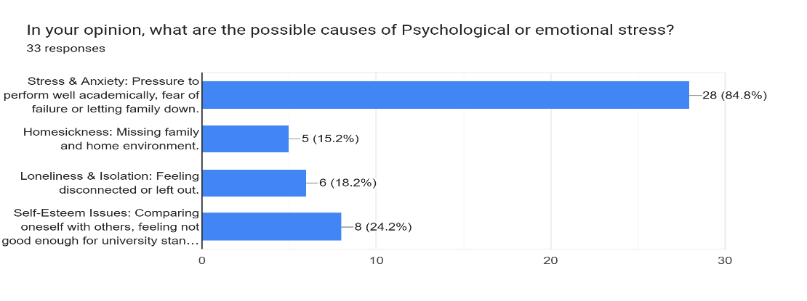

3. Administrative or University Management Problems (18.2% of all reported issues)
Lack of clear information and poor guidance are the top administrative bottlenecks.
- Information & Guidance (48.5%): This is the leading administrative issue, concerning a lack of clarity about rules or procedures and a poor orientation or advising system.
- Registration & Facilities (45.5%): Significant problems are reported with complex course registration or schedule clashes, and poor library, Wi-Fi, or lab access (Facilities).
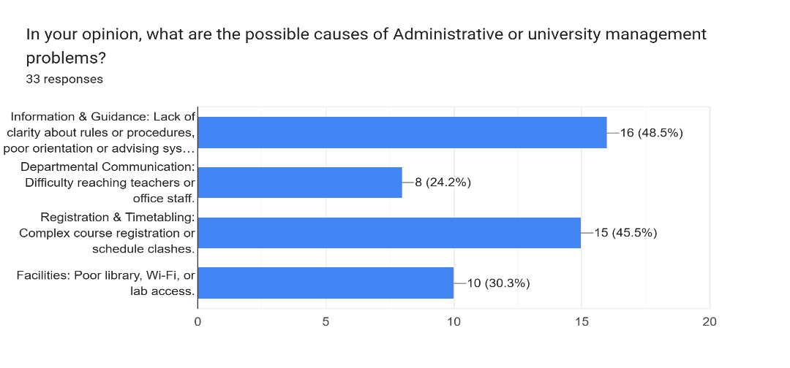

4.Career & Future Uncertainty:
This category shows a clear need for professional development support:
- Career Guidance (54.5%): Nearly 40% of uncertainty stems from a lack of counseling or information about career options.
- Future Anxiety (45.5%): Closely related is the fear of unemployment or uncertain job market.

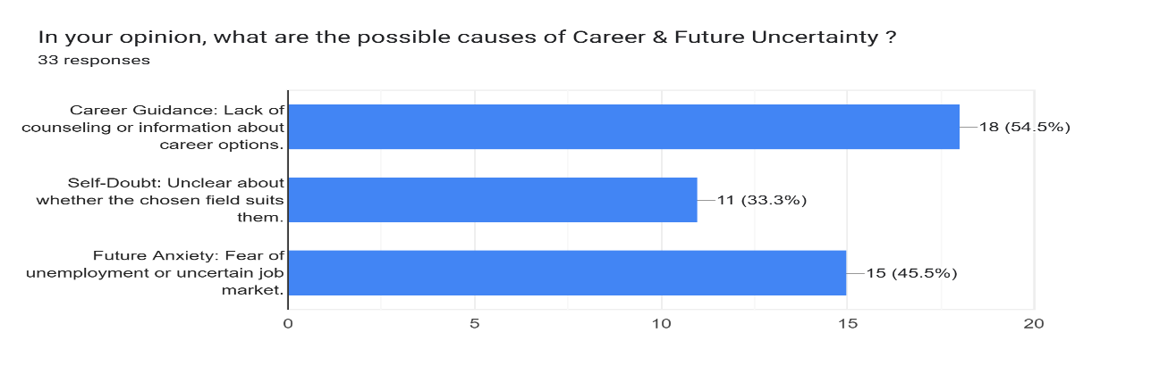

- Accommodation or Hostel-Related Issues:
The living environment is a major challenge for resident students.
- Hostel Conditions (69.7%): The dominant problems are poor hygiene, lack of facilities, or overcrowding.
- Food & Health (45.5%): Concerns also include poor quality or limited food options and falling sick due to the new environment.
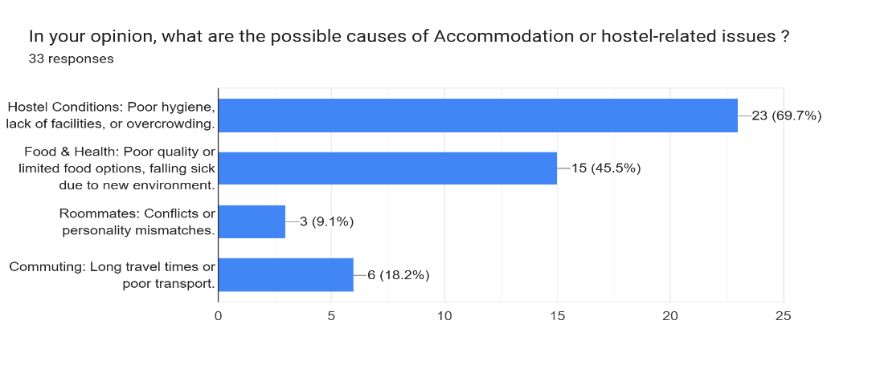

- Health and Lifestyle Problems:
Mental health and basic lifestyle habits are equally important areas of concern.
- Mental Health (51.5%): The vast majority of health issues relate to Depression, burnout, or chronic stress.
- Sleep & Nutrition (60.6%): Poor eating habits or irregular sleep is a major lifestyle problem.

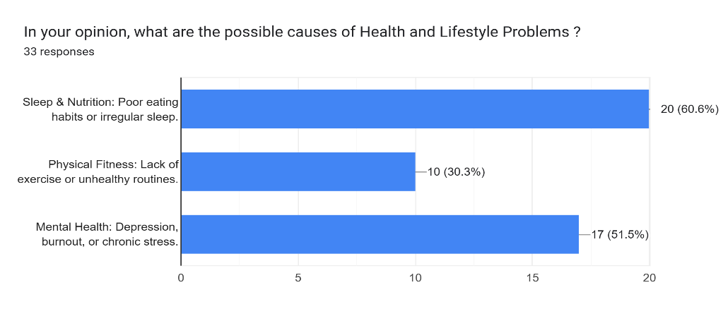

- Social & Interpersonal Problems:
Social integration is a hurdle for many freshers.
- Making Friends (57.6%): The single biggest social problem is Shyness/social anxiety and difficulty finding like-minded peers.
- Peer Pressure (42.4%): Pressure to fit in or behave a certain way is a distinct social challenge.

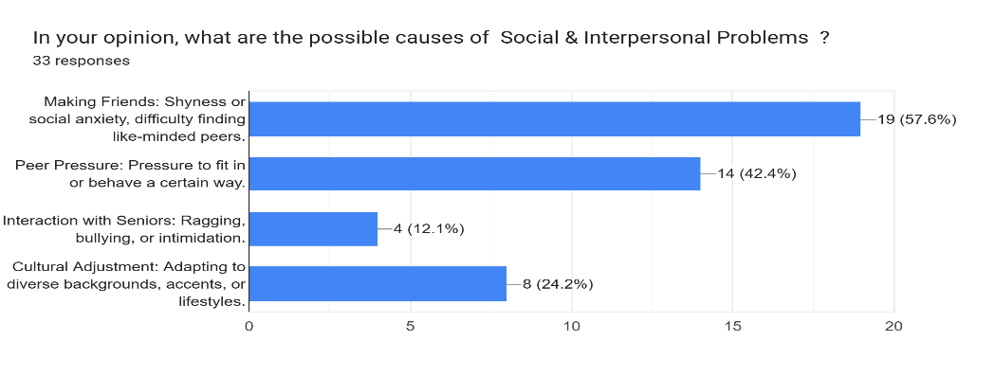

- Financial Problems:
- Tuition Fees (63.6%): The high or rising costs of education are the top financial concern.
- Living Expenses (33.3%): A combination of Hostel, rent, food, and transportation expenses is a major burden.
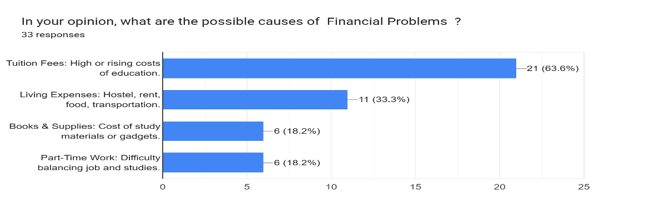

- Academic Performance :

A significant proportion (66%) of the fresher cohort scored high marks (1020 or above) in their previous academic examination, with 35% scoring 1080-1139 and 31% scoring 1020-1079. This suggests that the cohort has a strong academic foundation, making it unlikely that academic problems are due to lack of aptitude or diligence. Instead, other factors might be contributing to the reported academic issues.
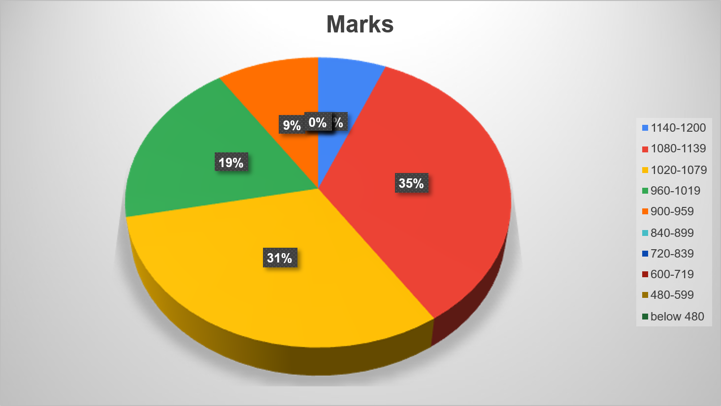

- Stress Analysis :

The majority (60%) of freshmen reported high stress levels (4 or 5 out of 5), indicating poor well-being. Only 7% reported the lowest stress level. High stress is linked to reduced academic performance, higher attrition rates, and increased demand for mental health services. Academic and administrative issues are likely contributing to this stress. Addressing these root causes is essential to mitigating emotional stress. The findings highlight the need for accessible psychological support resources.

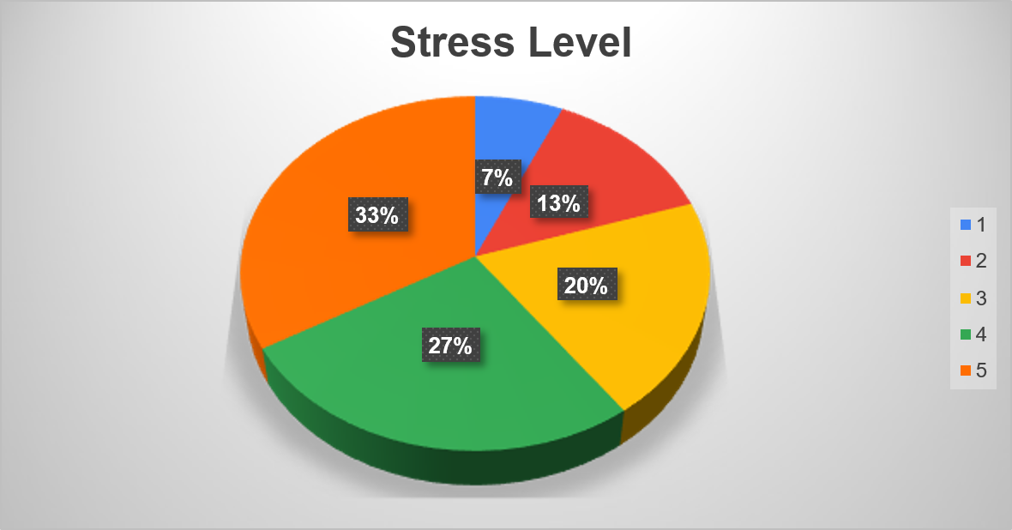

Findings
The analysis reveals that:
1.Academic Overload:
The volume and pace of coursework, coupled with a lack of clarity regarding assignment submission and assessment methods, constitute the single largest source of reported stress. Students feel unprepared for the intellectual demands and the self-directed nature of university study.
2. Administrative Friction:
Frequent complaints regarding "University Management" and "Facilities" (e.g., poor Wi-Fi, lab access) highlight operational inefficiencies that distract from learning. A lack of transparent communication regarding fees and schedules creates unnecessary anxiety.
3. Well-being Crisis:
A significant percentage of freshers linked their problems to Psychological or emotional stress and Health and Lifestyle issues. This confirms the critical need for robust, accessible mental health and lifestyle guidance (e.g., sleep, exercise, and nutrition) often neglected in the transition phase.

Discussion

This survey provides compelling evidence that the current orientation and support structures are insufficient. The discussion centers on the imperative to prioritize student success by removing structural friction. The consistent call for "Less academic stress" and "Better Guidance" translates directly into implementable solutions: mandatory transition workshops covering study skills and time management, and a formal review of course load balance. Furthermore, the administrative and infrastructural criticisms (e.g., "Improve management," "better class timetable") are foundational. These logistical shortcomings erode trust and compound academic stress. To secure long-term student retention and performance, the institution must immediately focus resources on establishing transparent, student-centric policies and modernize the academic environment.

Suggestions

- Reduce Course Load and avoid complex subjects not relevant to the student's career (e.g., MWM for Computer Engineering, CS, AI, CYS students).
- Teachers should be more clear about what they teach and about the assignments.
- Provide proper academic guidance and time management training to reduce study pressure.
- The university system must be updated and changed to facilitate students, as the current system is poor and lacks facilities.
- The University management and faculty must show some kind of leniency towards freshers as they struggle with the new environment.
- Management of the university must create a balance between assignments and workload.
- Improve management: students should be free to ask any question, and the "rat race system" should be ended.
- Focus on physical activities for fitness and events for entertainment, and prepare students about their career.
- Communication between students and faculty should be improved.

Conclusion

The survey, titled 'University Fresher Problem Report', concludes that the transition to university life is challenging due to multi-dimensional and interconnected issues. The primary concern is Academic Overload, driven by heavy coursework, fast pace, and inadequate guidance, which contributes significantly to the fact that the majority of freshers (60%) report high stress levels. Administrative Friction, such as poor communication and facility issues, compounds this stress. Since the cohort possesses a strong academic foundation, the institution must prioritize removing these structural barriers, implementing mandatory study skills workshops, and modernizing the environment to ensure a supportive and comfortable experience for future students.

